**Aspect Oriented Programming - (AOP)**

Functional Programming :

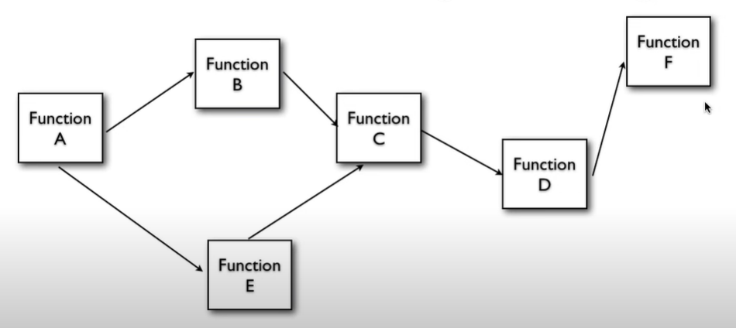

Object Oriented Programming :

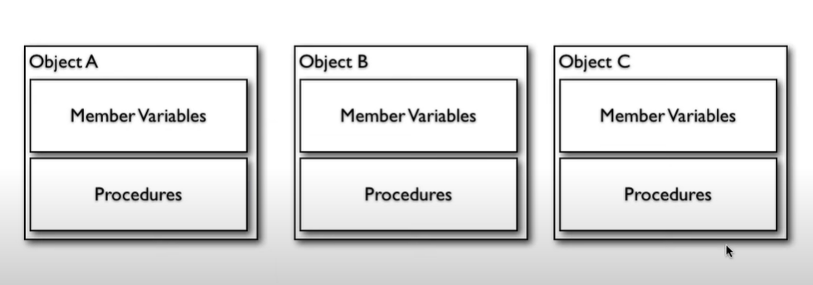

Aspect Oriented Programming :

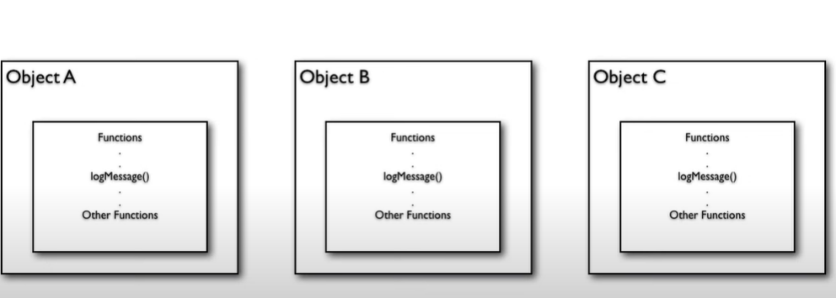

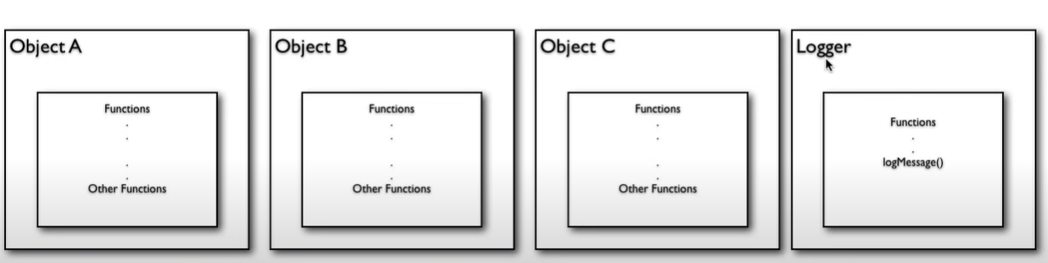

Problems :

* Too many relationships to the cross cutting objects.
* Code is still required in all methods
* Can’t all be changed at once

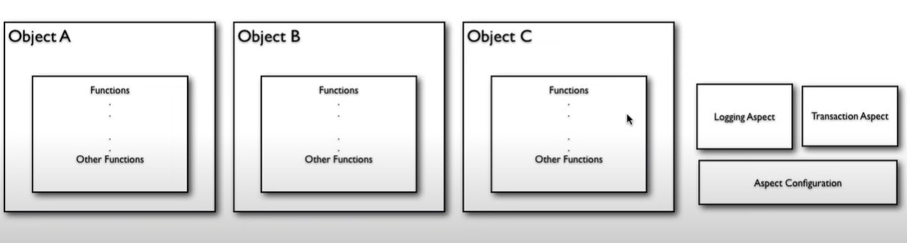

* We create aspects, and to manage those aspects, we have aspect configuration. The configuration handles all the aspects to be processed accordingly.

Cross Cutting Concerns – Cross cutting concern i.e those concerns which are not related to any particular layer like security, logging, transactions etc.

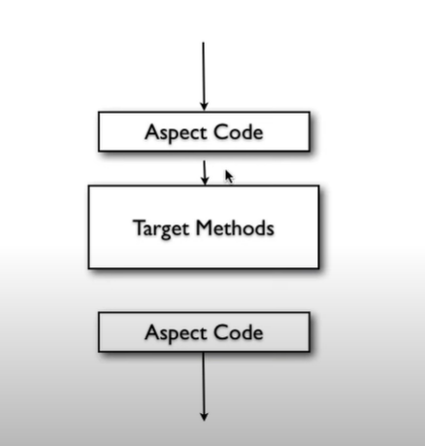

**Steps in AOP**

* Write Aspects
* Configure where the aspects apply.